**GOVERNMENT ARTS COLLEGE, DHARMAPURI-636705.**

**DEPARTMENT OF ELECTRONICS & COMMUNICAION**

**AFFILIATED TO PERIYAR UNIVERSITY**

**2023-2024**



**PROJECT COMPLETION REPORT**

PROJECT TITLE

SUBSCRIBERS GALORE:

EXPLORING WORLD’S TOP YOUTUBE CHANNEL.

SUBMITTED BY:

1. ARUNKUMAR R C21UG105ELC005

2 . DHANUSH V C21UG105ELC006

3 . JAYAKUMAR K C21UG105ELC010

4 . SANTHOSHKUMAR A C21UG105ELC023

INTRODUCTION:

Youtube is an online video sharing and social media platform headquartered in San Bruno,California,United States . Accessible worldwide,it was launched on February 14,2005,by Steve Chen,ChadHurley,and Jawed Karim.It is owned by Google and is the second most visited website in the world,after Google search.



Empathy map:

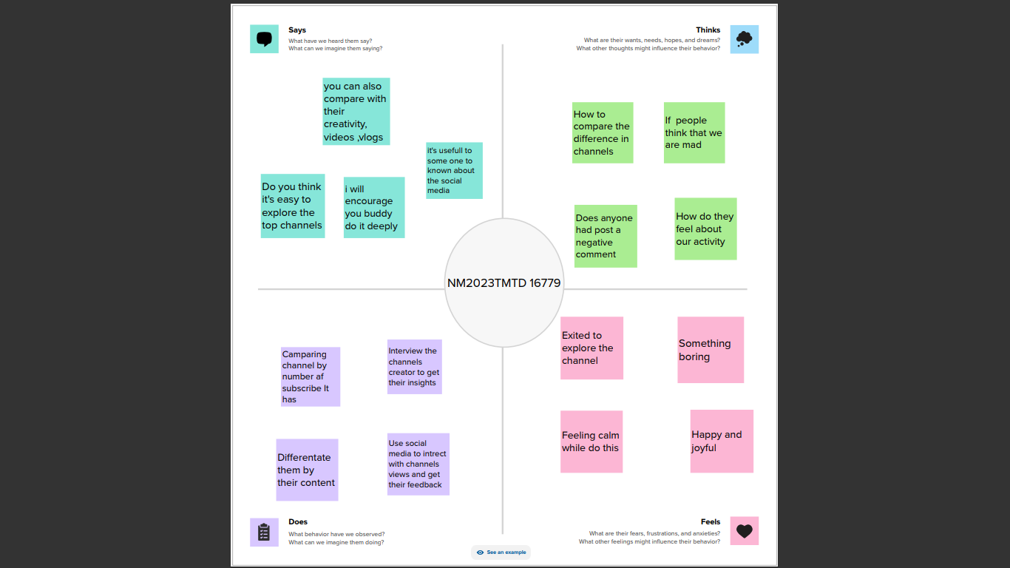

Brainstorming map:

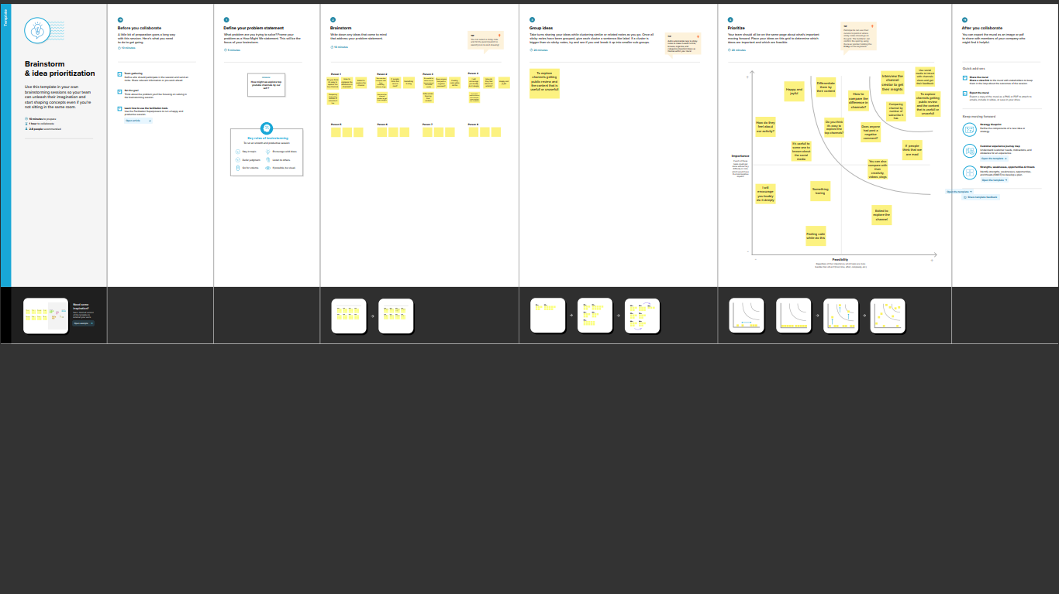

Video player types by youtube:

Design history of the video player used by Youtube .Note that Each layout generation might have gone through minor undocumented

Iterations, and that appearance may vary with embedding

Parameters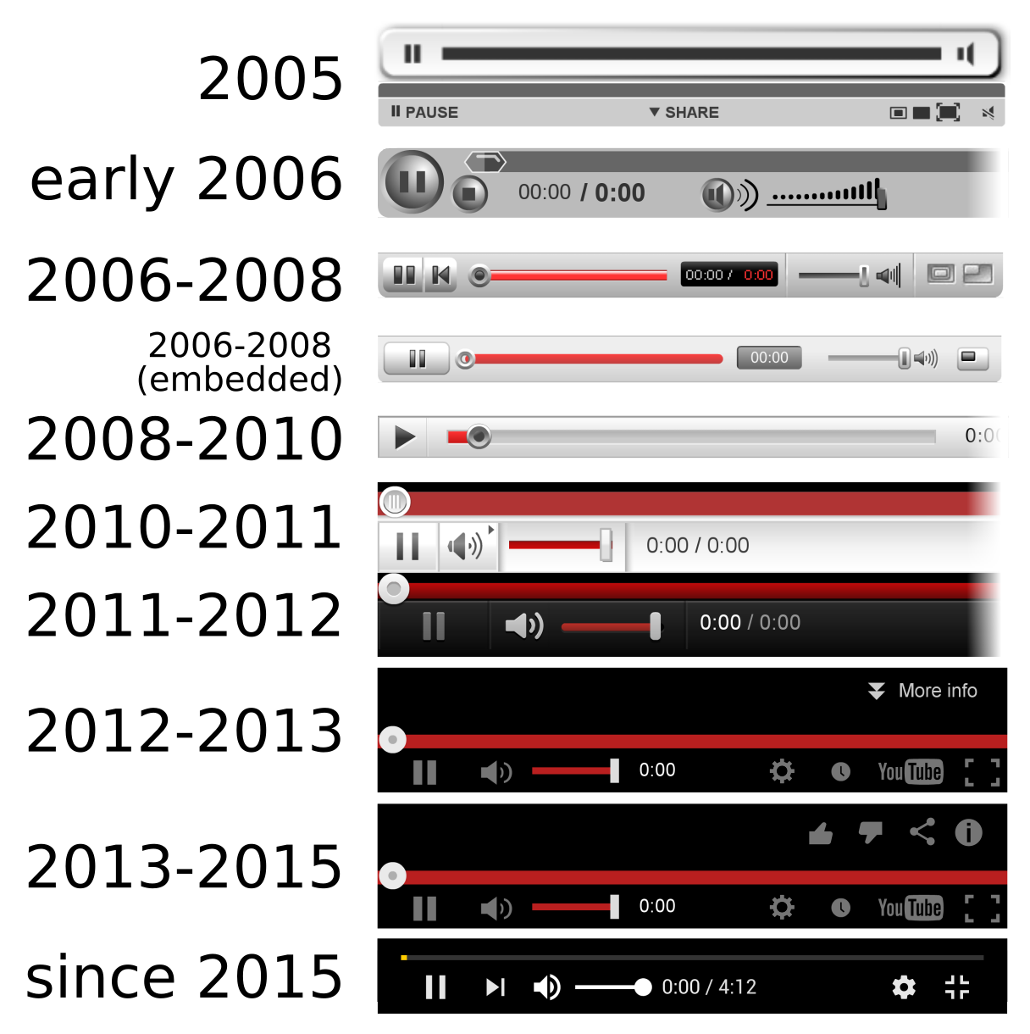.

Advantages:

* This project is help full to the new youtube users to identify which type of content has higher subscribers and views and helps to growth in the social media
* Its helpfull to understand which country has highest percentage of subscribers
* It also usefull to overview to which content based channels are presented in different countrys
* It helps to understand about social media and how much they earned and how they got promoted as a branded channels

Dis advantages:

* The main dis advantage about the project is it is difficult to collect and analyse the datas like number of subscribers , which Rank , which content based etc,…
* It’s difficult to orginate the channels in the rank wise and channel wise
* Bad comments and audio when you first begin publishing videos about this project and ppts.
* It requires lot of time and datas for collecting and analyzing the data

Conclusion:

In the spirite of exploratory data anylysis , we did not start from strict research question , but proceed mainly descriptively to provide a broad overview that can searve as a point of reference for researchers focusing on topic or user samples . our main goal was to ‘map’ youtube , not necessarily in visual terms , but with attention to various stratifying and sturucturing elements that , in part ,are established by youtube itself , for example when it comes to access to monetization through advertising or through the internal automated channel category system



THANK YOU